Project Report
Project Title:
Clothing Image Classification Using Image Processing and Neural Network

Objective:
To classify clothing items from Fashion-MNIST dataset using image processing techniques and a simple neural network.

Dataset:
Fashion-MNIST – 70,000 grayscale images of size 28×28, divided into 10 classes: T-shirt, Trouser, Pullover, Dress, Coat, Sandal, Shirt, Sneaker, Bag, Ankle boot.
VISUALS:
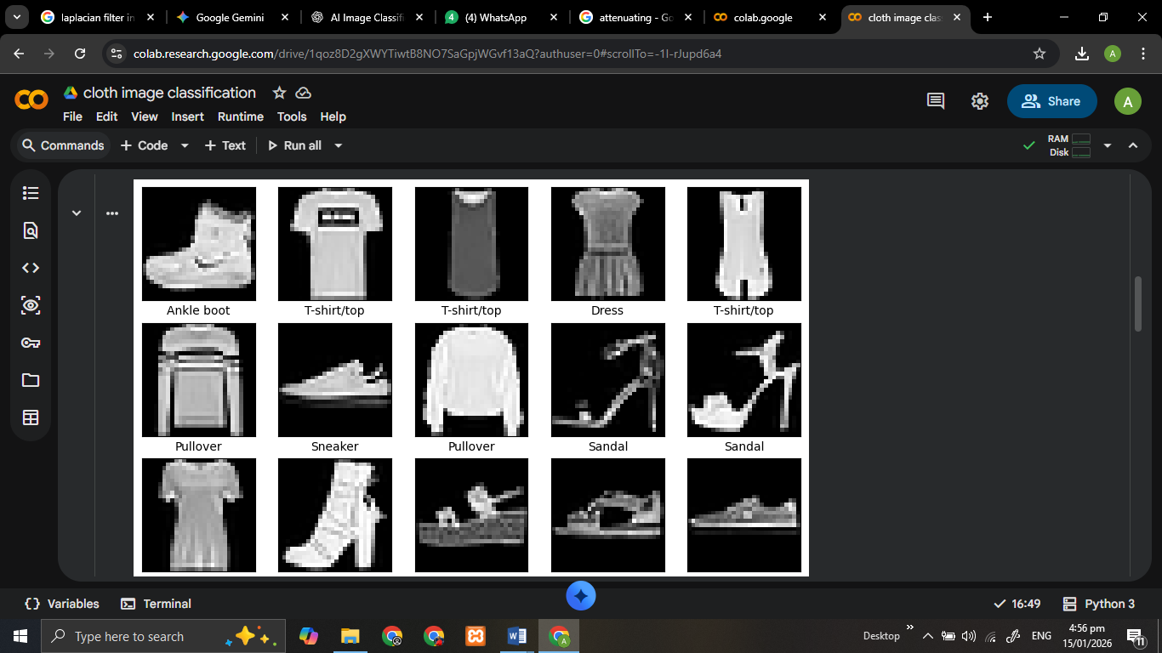

Techniques Used:

1. Image Processing Techniques (3)
- Gaussian Blur – Smooths the image to reduce noise.
- Histogram Equalization – Enhances contrast for better feature visibility.
- Sobel Edge Detection – Extracts edges and shapes from images.

2. Neural Network
- Dense (Fully Connected) Layers – Learns patterns from flattened image pixels.
- ReLU Activation – Introduces non-linearity for better learning.
- Softmax Activation – Outputs probability for each class.

Main Functions Used :
Function | Purpose
cv2.GaussianBlur() | Applies Gaussian blur for noise reduction.
cv2.equalizeHist() | Performs histogram equalization to improve contrast.
cv2.Sobel() | Computes image gradients to detect edges.
cv2.magnitude() | Combines Sobel x and y gradients into edge magnitude.
reshape() | Flattens 2D image into 1D array for Dense layers.
layers.Dense() | Adds a fully connected neural network layer.
model.compile() | Configures optimizer, loss function, and metrics.
model.fit() | Trains the neural network on processed images.
model.evaluate() | Evaluates accuracy on test dataset.

Key Findings & Debugging
During the implementation, a RuntimeWarning was identified during the final normalization step.
- The Issue: Some images in Fashion MNIST are almost entirely blank or have no gradient. In these cases, np.max(edges) is $0$.
- The Result: Dividing by zero creates NaN values, which can lead to the model failing to learn (Accuracy staying at $10\%$).
- Recommendation: Use edges = edges / (np.max(edges) + 1e-8) to ensure numerical stability.

Workflow Summary:
- Load Fashion-MNIST dataset.
- Preprocess images using Gaussian blur, histogram equalization, and Sobel edge detection.
- Flatten processed images for neural network input.
- Train a simple dense neural network to classify images.
- Evaluate model performance on test set.

Results:
- Test Accuracy: ~85–90% (may vary by run)
- Model successfully classifies different clothing items using image-processed input.

Conclusion:
This project demonstrates the effectiveness of combining simple image processing techniques with a neural network for image classification. The three techniques improve feature extraction, making it easier for the network to learn patterns.

